SOP: Product Group Stock Limit Configuration

Search Customer
- Navigate to Customer Management.
- Search the customer using Customer ID or Customer Name.
- Open the customer record.
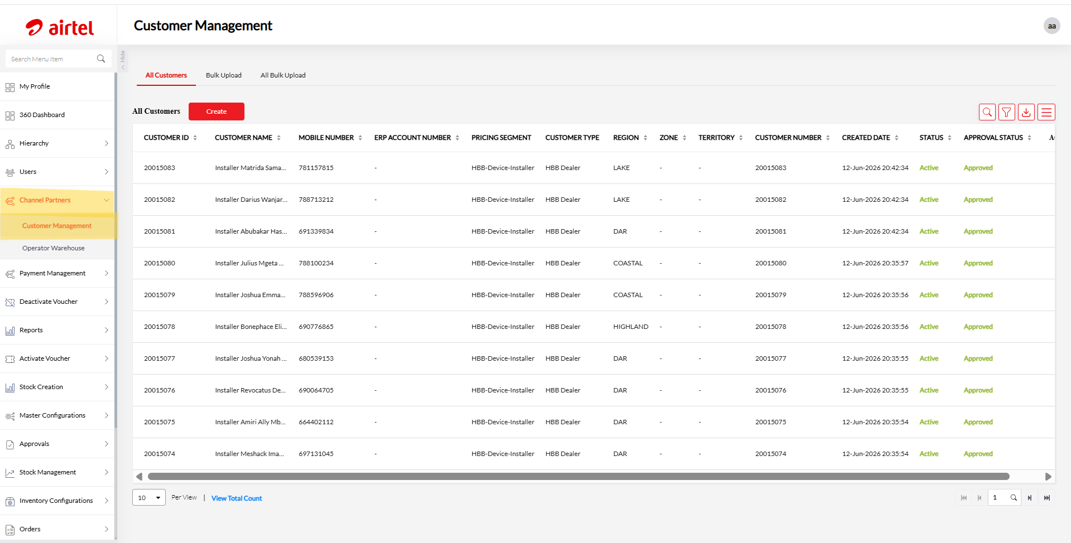

Open Product Group Stock Limit
- Click on View Customer Info.
- Navigate to Profile.
- Select Product Group Stock Limit.
- Under Actions, click Service Request.
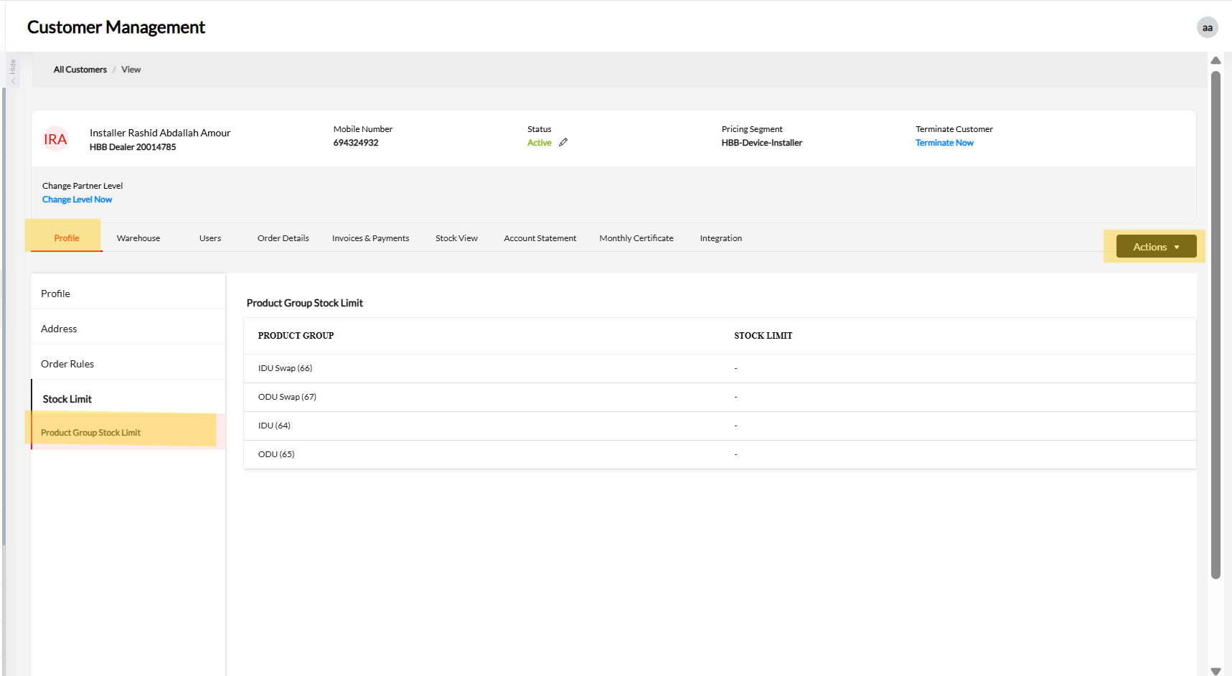

Create Product Group Stock Limit Request
- In the Service Request screen, select Product Group Stock Limit.
- Select the required Product Group.
- Enter the required Limit.
- Click Add.
- If already limit is set , click on pencil icon to edit the existing limit and click on update
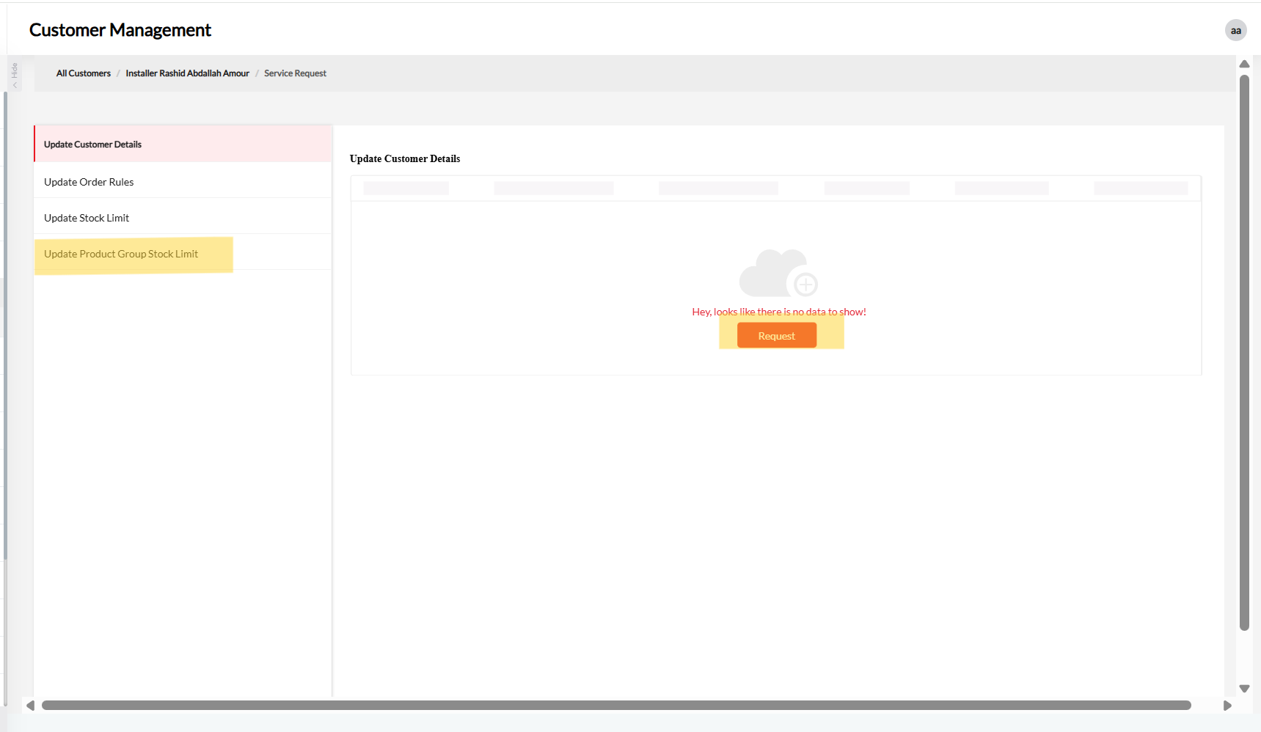
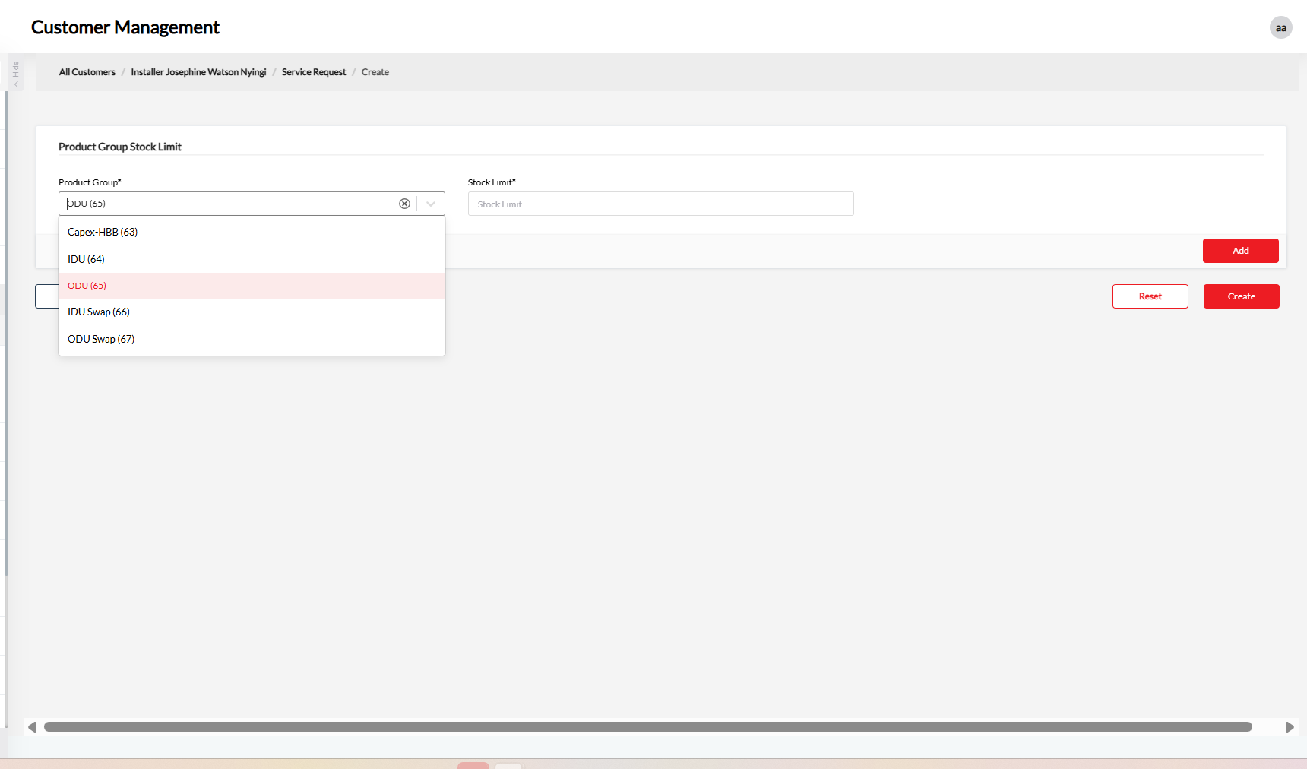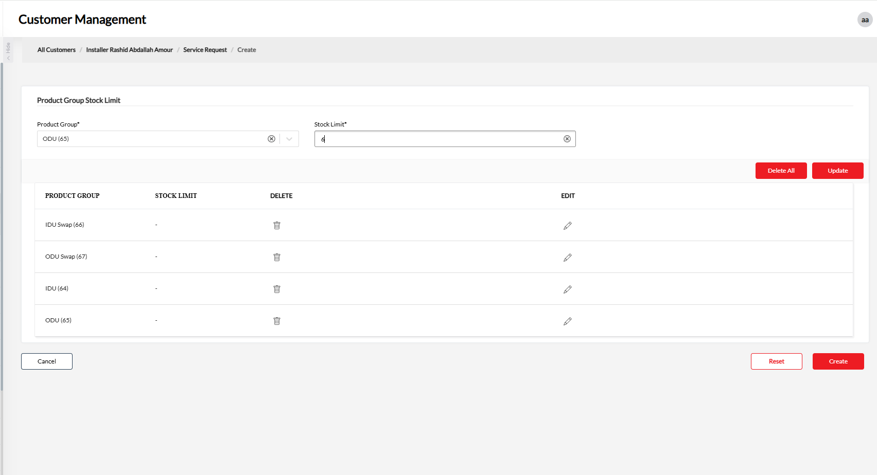

Submit Request
- Verify the Product Group and Limit details.
- Click Create.

Approval Process
- Once the request is created, it will be submitted for approval.
- Track the request status through the approval workflow.
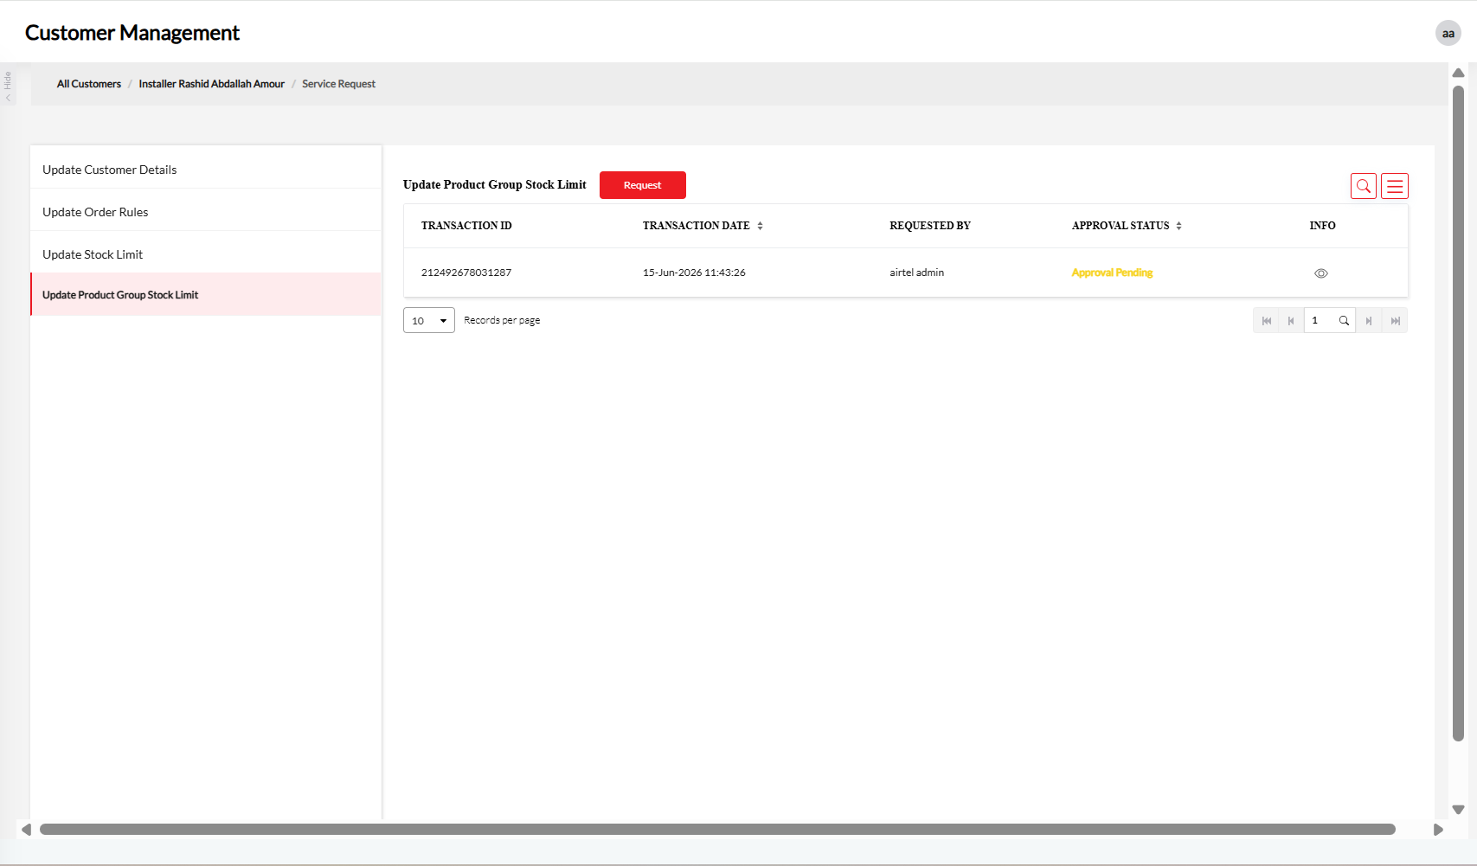

Related tables and queries for backend changes
CPMUSER.SD_PRODUCT_GROUP_STOCK_LIMIT
SELECT NAME ,PLANCODE,PRODUCTSUBTYPE FROM UPCUSER.UPC_PO_MASTER upm WHERE POGROUP = '7008'
Sample insert query:
INSERT INTO CPMUSER.SD_PRODUCT_GROUP_STOCK_LIMIT (ENTITY_TYPE, ENTITY_ID, PRODUCT_GROUP_ID, PRODUCT_GROUP_NAME, "LIMIT", CREATED_BY, CREATED_DATE, LAST_MODIFIED_DATE, LAST_MODIFIED_BY) VALUES (1, '20014717', '67', 'ODU Swap', 0, '32008488', CURRENT_TIMESTAMP, CURRENT_TIMESTAMP, '32008488');

"id" : "63",
"name" : "Capex-HBB"

"id" : "64",
"name" : "IDU"

"id" : "65",
"name" : "ODU"

"id" : "66",
"name" : "IDU Swap"

"id" : "67",
"name" : "ODU Swap

SUBGROUP ID | PRODUCTSUBTYPE | NAME | PLANCODE
IDU | 64 | Huawei 5G CPE H352-381 | 200009239
IDU | 64 | Tozed 5G CPE ZLT X28 (CAPEX) | 200007453
IDU | 64 | ZLT X25A 5G CPE | 200007944
IDU | 64 | TOZED X25PRO 5G CPE CAPEX | 110149614
IDU | 64 | ZLT X15-W51M ODU/IDU | 200009373
ODU | 65 | TYR 300 ODU Set (Tongyu) | 110153565
IDU Swap | 66 | Tozed 5G ZLT X25 MAX 2 Swap | 110153006
IDU Swap | 66 | ZLT X15-W51M ODU/IDU Swap | 200009374
IDU Swap | 66 | TOZED X25PRO 5G CPE - CAPEX SWAP | 110149615
IDU Swap | 66 | Tozed 5G CPE ZLT X28 (CAPEX)Swap | 200007452
IDU Swap | 66 | ZLT X25A 5G CPE Swap | 200007945
ODU Swap | 67 | TYR 300 ODU Set (Tongyu) Swap | 110153566

BEGIN
FOR us IN (
SELECT
mslu.PARTNER_ID,
sgd.SUB_GROUP_ID,
sgd.SUB_GROUP,
mslu.STOCK_LIMIT
FROM CPMUSER.MSO_STOCK_SUBGROUP_LIMIT mslu
JOIN CPMUSER.MSO_SUB_GROUP_DTLS sgd
ON UPPER(mslu.SUB_GROUP_NAME) = UPPER(sgd.SUB_GROUP)
JOIN CPMUSER.SD_PARTNER_MASTER spm
ON mslu.PARTNER_ID = spm.PARTNER_ID
)
LOOP
MERGE INTO CPMUSER.SD_PRODUCT_GROUP_STOCK_LIMIT spsl
USING DUAL
ON (
spsl.ENTITY_ID = us.PARTNER_ID
AND spsl.PRODUCT_GROUP_ID = us.SUB_GROUP_ID
)
WHEN MATCHED THEN
UPDATE SET
spsl."LIMIT" = us.STOCK_LIMIT,
spsl.LAST_MODIFIED_DATE = CURRENT_TIMESTAMP,
spsl.LAST_MODIFIED_BY = '6000000002'
WHEN NOT MATCHED THEN
INSERT (
ENTITY_TYPE,
ENTITY_ID,
PRODUCT_GROUP_ID,
PRODUCT_GROUP_NAME,
"LIMIT",
CREATED_BY,
CREATED_DATE,
LAST_MODIFIED_DATE,
LAST_MODIFIED_BY
)
VALUES (
1,
us.PARTNER_ID,
us.SUB_GROUP_ID,
us.SUB_GROUP,
us.STOCK_LIMIT,
'6000000002',
CURRENT_TIMESTAMP,
CURRENT_TIMESTAMP,
'6000000002'
);

IF SQL%ROWCOUNT > 0 THEN
DBMS_OUTPUT.PUT_LINE(
'Processed Record: ' || us.PARTNER_ID || ','
|| us.SUB_GROUP_ID || ','
|| us.SUB_GROUP || ','
|| us.STOCK_LIMIT
);
END IF;
END LOOP;
END;

